Blueberry Smoothie

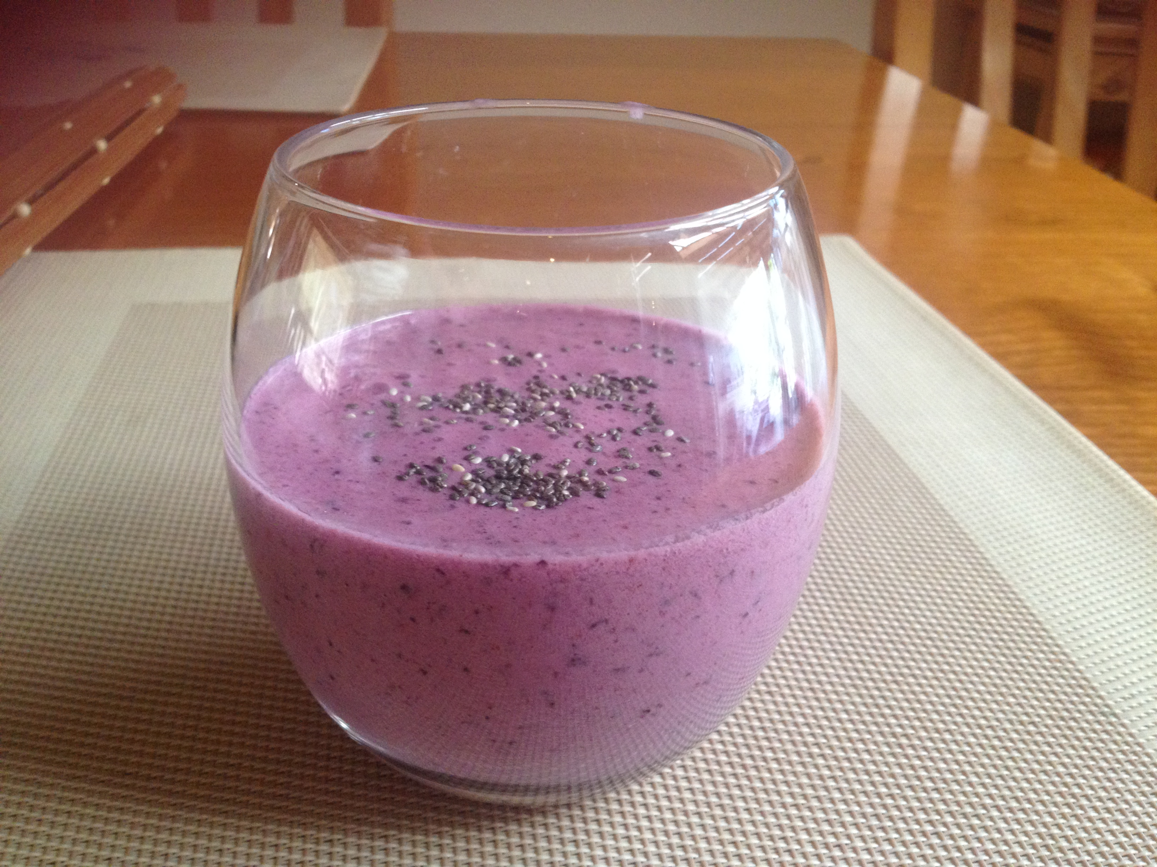

Serves 1

Ingredients

1 cup frozen blueberries
1 tablespoon plain yoghurt
1 tablespoon honey
Chia seeds (optional)

Method

Place all ingredients in a blender
Sprinkle a small amount of chia seeds on top

