Coconut and Pear Chocolate Chip Muffins

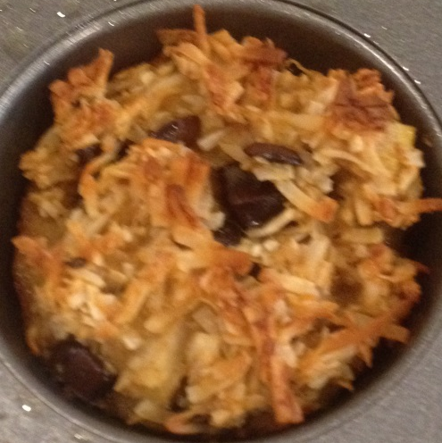
Ingredients

1 ½ cups desiccated/shredded coconut
1 pear (diced small)
½ cup choc chips
1 teaspoon baking powder
2 eggs
1 teaspoon vanilla extract
60 ml (1/4 cup) light olive oil
60 ml milk (¼ cup)
2 tablespoons honey

- Mix all ingredients together in a large bowl.
- Spoon into muffin/cupcake tin
- Bake for 20 min at 180 degrees

