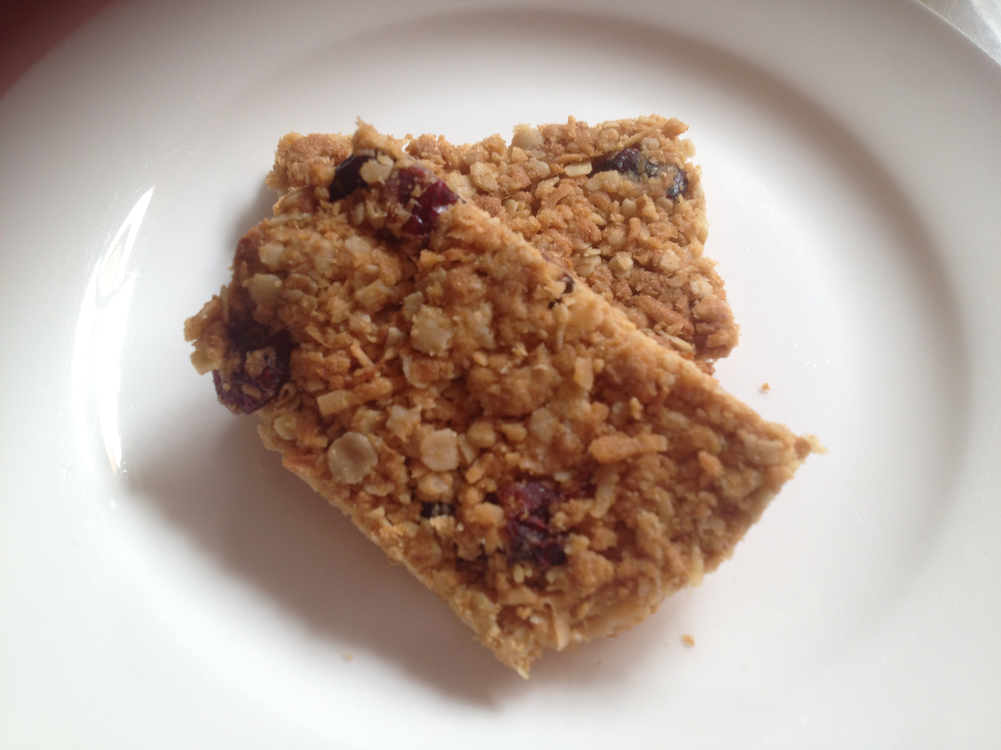

**Oat Slice**

**Ingredients:**

1 cup Rolled Oats

1 cup Desiccated Coconut

1 cup Self Raising Wholemeal Flour

2/3 cup brown sugar lightly packed

125 grams butter

2 tablespoons golden syrup

1 tablespoon boiling water0.5 teaspoon bicarbonate of soda

**Method:**

1. Preheat oven to a low-med temperature (approx 160).
2. Mix together all the dry ingredients – rolled oats, coconut, flour and sugar. If you are doubling the mixture then you need to use a large bowl.
3. Chop butter and melt butter with golden syrup on a low heat.
4. Add bicarbonate of soda to boiling water and stir.
5. Add this liquid to the melted butter and mix.
6. Pour butter mixture into the dry ingredients and combine well.
7. Press firmly into a lined baking tray.
8. Cook for 15 – 20 minutes, until golden on top.
9. Allow slice to sit for 10 minutes before removing from tray and placing on cooling rack.
10. Allow the slice to cool for at least another 15 minutes before cutting up into fingers.