Pumpkin and Ginger Soup
By Jamie Oliver
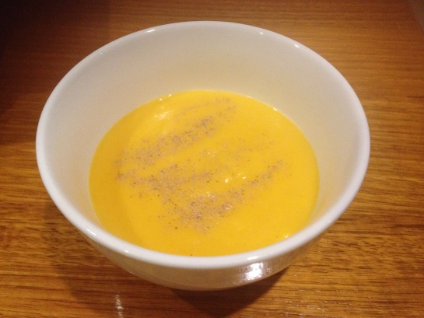
Ingredients

1 kg Butternut pumpkin
(chopped)
2 shallots
75g grated ginger
1 litre vegetable stock
125ml coconut milk
½ tablespoon chilli powder

- Sautee the pumpkin shallots and grated ginger with a good splash of olive oil till soft.
- Add vegetable stock, coconut milk and chilli, season, bring to the boil, then simmer for 40min.
- Pour into a food processor and blend until smooth.
- Check seasoning, then serve with fresh herbs such as chives, min a squeeze of lime juice and extra splash of coconut milk if needed.
Tip: If there are ingredients you don’t have, use something similar e.g fresh milk for coconut milk. Feel free to add other vegetables in e.g sweet potato or carrots.
Enjoy what you are eating and cook to create something special!
For more yummy Jamie Oliver Recipes visit jamieoliver.com

