Yoghurt and blueberry

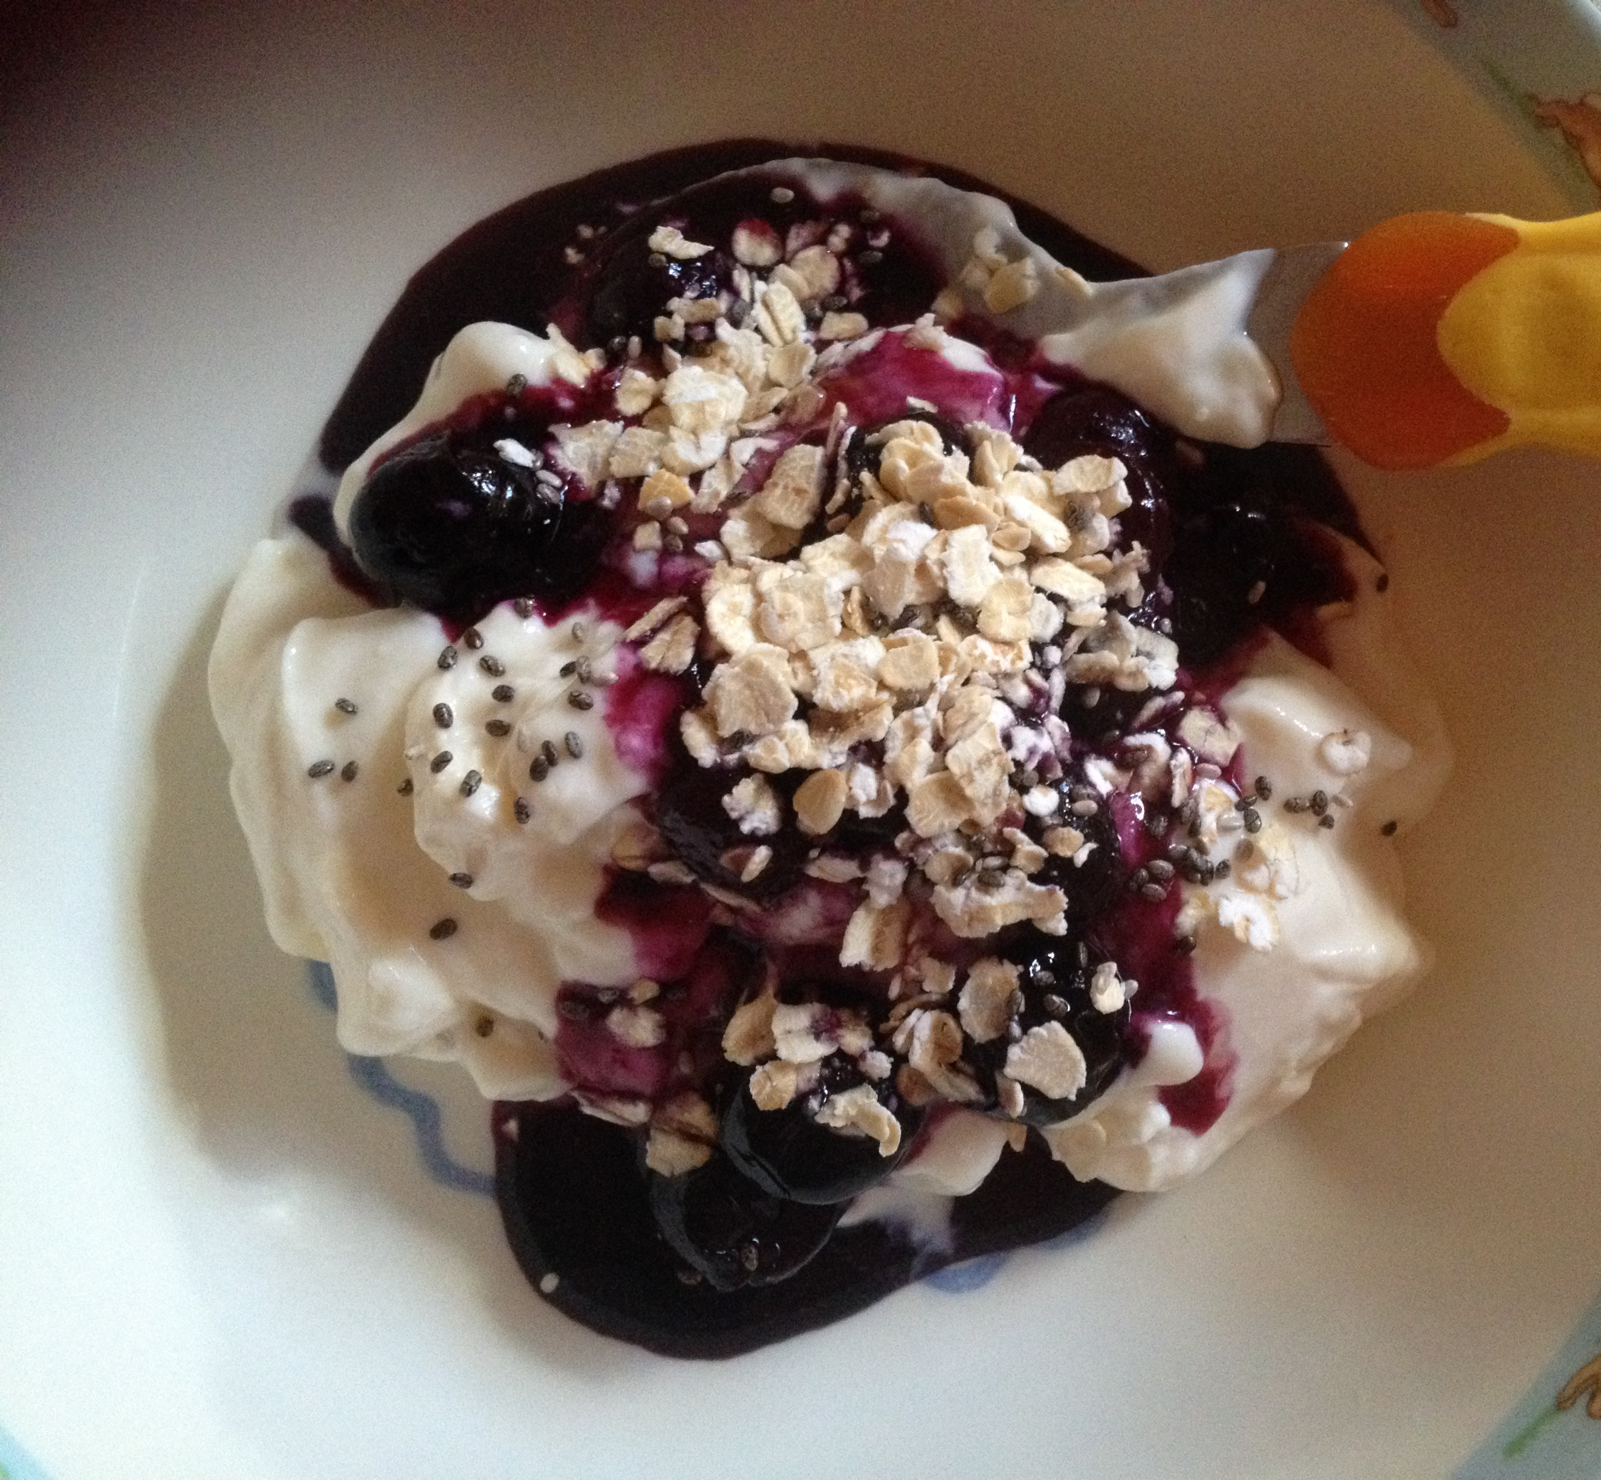

Ingredients

Plain or vanilla flavoured yoghurt
Frozen blueberries
Oats
Chia seeds

Method
1. Defrost ¼ cup of frozen blueberries in the microwave for about 2min (keep an eye on it)
2. Let the blueberries cool (5min)
3. Place a desired scoop of yoghurt into a bowl
4. Spoon the blueberries on top
5. Sprinkle with oats and chia seed

